Children’s Art Analysis
Rachel Newman
University of Missouri

CHILDREN’S ART ANALYSIS
Although educators are often expected to know each student as a whole child, rarely does this include a student’s artistic development. The powers above teachers have driven classroom educators to focus on development processes that are “essential” to knowing the whole child. Thus, teachers focus on students’ physical, emotional, social, and cultural stages of development. These development processes are vital to knowing each child, yet alone they do not account for the creative mind that teachers also need to develop in students. A creative mind is one that welcomes critical thought, analysis, and is able to synthesize all information- visual, written, auditory, etc. A focus on students’ artistic development offers a solution for preparing children to thrive in a world constantly searching for meaning and purpose (Pink, 2006). Guiding art education instruction in the classroom through Lowenfeld’s stages of artistic development is one way for teachers to encourage the development of creative minds. Through analyzing children’s artwork in accordance with Lowenfeld’s stages of artistic development, teachers learn of developmental-appropriate art tasks that will help individual students grow into critical thinkers of the world around them. In addition to highlighting the importance of knowing children as artists, this paper also provides an example of a student art analysis.
STUDENT ART ANALYSIS (PICTURE BELOW)
Without any cultural or social development context for the student artist of the attached picture, this artist’s drawing indicates that he or she is in the schematic stage of artistic development. Lowenfeld predicts that children in this stage fall between seven to nine years of age (Erickson & Young, 1996). Although this drawing contains some characteristics common to the scribbling and gang stage, the schematic stage predominantly characterizes this work. The artist establishes a base line in the scribbles at the bottom of the page. These scribbles represent the ground while the space around the bumblebee is air and the scribbles on the top of the page represent the sky. This artist has not begun to think of drawing on a plane, which is characteristic of artists in the gang stage. The body and legs of the bumblebee are also made of geometric shapes that would be meaningless if taken out of the context of this drawing. The geometric shapes used are line segments and an oval is used to represent the body. While a gang stage artist commonly explores depth in a piece, this artist’s work is merely two-dimensional (Brittan & Lowenfeld, 1970).
The scribbling in this piece (characteristic of the scribbling stage) and detail added in the bumblebee’s stripes (characteristic of the gang stage) suggest that this artist is between these two stages. An entry point for instructing this student would be to ask if there is a way the ground and sky could be represented differently. This question probes the student to move beyond scribbles and visualize something more detailed. Another point of instruction would be to say that the detail in the bumblebee is impressive and makes the piece really special. This positive feedback encourages the student to think about detail, a characteristic of the gang stage, in future pieces. Scaffolding a student’s artistic development is also a way to encourage students to address work with an analytical eye, even at a young age.
IDEAS FOR TEACHING
Because teachers have a seemingly infinite number of demands placed on them already, the educational benefits of focusing on students’ artistic development gets lost under all the pressures of teaching. Teachers who take time to identify students’ artistic development know what “fair assessments” are and use this knowledge to develop the “whole potential of every child,” including “artistic thinking and visual literacy” (Luehrman & Unrath, 2006, p. 72). Visual literacy is as vital in today’s culture as textual literacy. The world expects its most productive citizens to gather meaning from all contexts: visual, textual, abstract, etc. A focus on artistic development in the classroom gives students the 21st century skills of critical thinking and analyzing. Through art education teachers also give students a realistic glimpse of what it takes to be successful in the work world today. Pink (2006) notes that “L-Directed white-collar work of all sorts is migrating to other parts of the world” (p. 38) and the jobs available will require perseverance in creative thinking.
In the absence of art education, teachers lose another means of knowing the whole child. In today’s world I don’t think anything could be more important than accessing and fostering a child’s ability to create, evaluate, and design. Students must recognize these skills in themselves to feel equipped for what the work world now demands. Without knowing students’ artistic development, teachers cannot be confident that they are delivering an education that students will find of high value in the future. Teachers lose sight of the most important skills they can give their students when they forgo art education in the classroom.
CONCLUSION
In conclusion, Lowenfeld’s stages of artistic development give general education teachers a framework for maturing students’ right-brain thinking. Analyzing children’s artwork in the context of Lowenfeld’s stages gives teachers a starting point for advancing students’ creative thinking skills. As the world demands its workers to create beauty and meaning out of the ordinary (Pink, 2006), placing importance on students’ artistic development could not be timelier. The purpose of education is to enable students to achieve prosperity, and if the world demands creativity and right-brain thinking, teachers must be the first people to meet this need.

FIGURE ONE
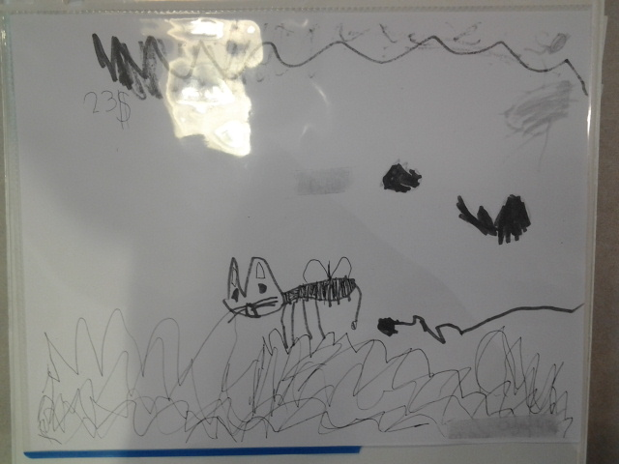

References
Brittain, W.L. & V. Lowenfeld (1970) Creative and Mental Growth. New York, NY. MacMillan Co. pgs 474-479.
Erickson, M. & Young, B. (1996). What every educator should (but maybe doesn’t know. School Arts, 40-42.
Luehrman, M. & Unrath, K. (2006). Making theories of children’s artistic development meaningful for pre-service teachers. Art Education, 6-12.
Pink, D. (2006). A whole new mind: Why right-brainers will rule the future. New York, NY: Penguin Group.

