Magazine Cover Design Using MS Word
Instructions

Step #1: Copy & paste the desired photograph into an MS Word document.

Step #2: Click on the imported image to reveal its sizing handles. Place your mouse cursor
on one of these handles (lower right corner of image is best) and press down on
the left mouse button. Holding this button down, you can resize the image.

To superimpose text or image over the main image:
- Go to INSERT
- Select TEXT BOX. From the drop down menu, select DRAW TEXT BOX. Place the cursor (probably a plus shape) somewhere on your photo, press down on the left button of your cursor, and drag the text box to the size you wish.
- For text, you can type directly into this box. Highlight and resize text, then, to the desired size. You may wish to change the text colorand/or bold it as well.
- For an image, you will need to drag the textbox to the approximate size you want; then, copy and paste the image into this text box.
- NOTICE (below) that the text box has a solid background. If you want the text box to disappear leaving only the text, click on the text box to reveal its handles. Then, go to DRAWING TOOLS along the top menu bar and click SHAPE FILL. Select NO FILL. If you wish to delete the textbox outline, click on SHAPE OUTLINE and select NO OUTLINE as well. Follow the same procedure to erase the textbox fill and outline for a textbox containing a photograph as well.

Cli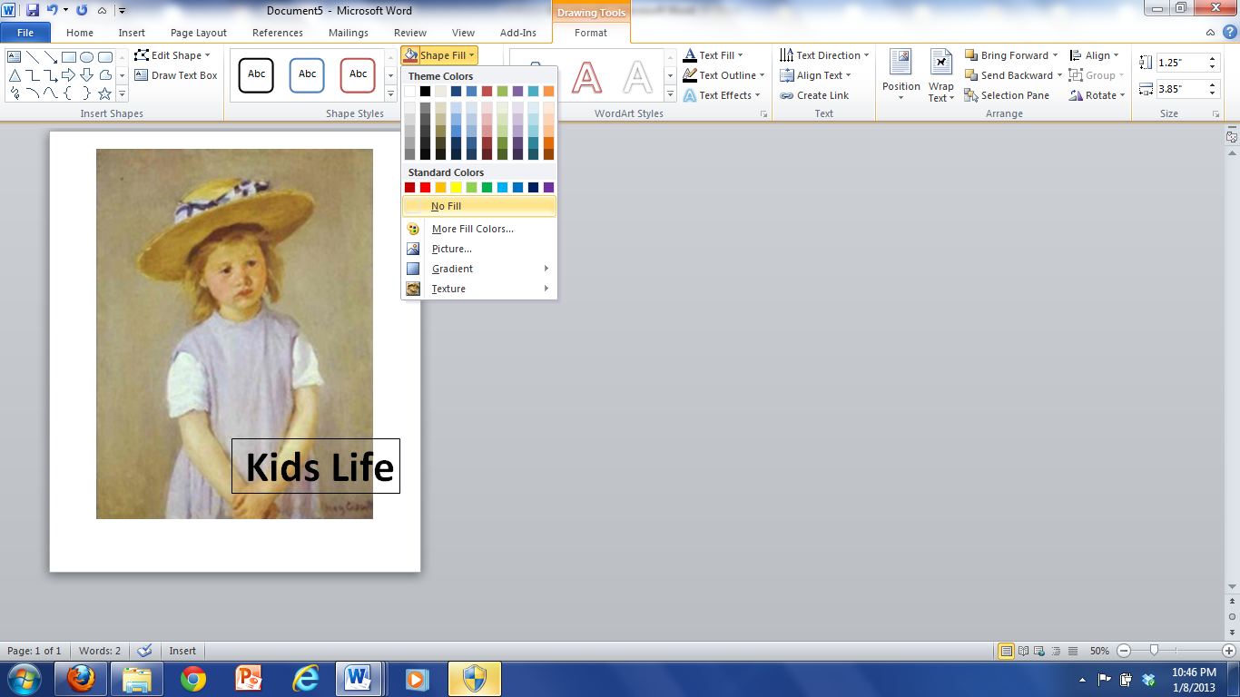
To outline text for contrast:
- Click on the text box containing the text
- Click on DRAWING TOOLS
- Select TEXT FILL to change the text color
- Select TEXT OUTLINE to outline the text w/ your choice of color

Photograph Special Effects
On MS Word, you will have a limited number of special effects to choose from which may add interest to your magazine cover design if you so desire.
- Click on the picture to make the PICTURE TOOLS tab appear on the menu across the top of the screen. Click on the PICTURE TOOLS tab to reveal your menu choices.
- Click on the COLOR option on the left end of the menu to change COLOR SATURATION, COLOR TONE, or to select RECOLOR.
- Click on ARTIST EFFECTS to do some interesting things with the texture of the photo

