Art Integration Lesson Plan Template
LTC 4240: Art for Children

Lesson Title & Big Idea: Wall of Strengths |  | Grade Level: 5
Lesson Purpose: In this lesson students will compose a class mural. The purpose of this activity is for each to learn a personal strength about another member of the class. Students will achieve this purpose by interviewing a partner, learning an individual strength about that person, and drawing a portrait of the partner demonstrating that quality. Through this procedure students are more likely to admire one another strengths instead of point out weaknesses. |  | Class Periods Required: 6-7 one hour class periods
Key Concepts (2-3):  - Families learn, grown, and seek inspiration in one another.  - Families exist in many contexts – classrooms, friends, churches, schools, and more.  - Family members comfort one another. | Essential Questions (2-3):  - What makes a family?  - How can a classroom be a family?
Lesson Objectives: (Excellent resource at http://www.teachervision.fen.com/curriculum-planning/new-teacher/48345.html?for_printing=1&detoured=1)
- Students will engage in Visual Thinking Strategy. Spanish Woman with a Tamborine by Henri Matisse will spark this thinking process.
- will work in partners to learn in detail the personal strengths of another member of the class.
- Students will ask questions to learn how their partners utilize their strengths.
- Students will collaborate with a partner to choose a personal strength to illustrate in a portrait.
- Students will communicate their partner’s strength to the rest of the class in a professional, respectful presentation.
Grade Level Expectations (GLEs) (3-4) (http://dese.mo.gov/divimprove/curriculum/GLE/)  Strand I: Product/Performance  1. Select and apply two-dimensional media, techniques, and processes to communicate ideas and solve challenging visual art problems  B. Painting  Grade 5: Mix a variety of hues to create new colors, Apply layers of watercolor paint from lightest to darkest colors  Strand I: Product/Performance  3. Communicate ideas about subject matter and themes in artworks created for various purposes.  A. Subject Matter: Fine Art  Grade 5: Portrait: Create a portrait from observation  Strand III: Artistic Perceptions (AP)  2. Analyze and evaluate art using art vocabulary  A. Art Criticism  Grade 5: Identify the type of artwork, Identify and explain symbolism or message communicated in an artwork | Missouri Core Academic Standards (Common Core State Standards)  (3-4) (http://www.corestandards.org/)  - CCSS.ELA-Literacy.SL.5.1 Engage effectively in a range of collaborative discussions (one-on-one, in groups, and teacher-led) with diverse partners on grade 5 topics and texts, building on others’ ideas and expressing their own clearly.  - CCSS.ELA-Literacy.SL.5.1a Come to discussions prepared, having read or studied required material; explicitly draw on that preparation and other information known about the topic to explore ideas under discussion.  - CCSS.ELA-Literacy.SL.5.1b Follow agreed-upon rules for discussions and carry out assigned roles.  - CCSS.ELA-Literacy.SL.5.1c Pose and respond to specific questions by making comments that contribute to the discussion and elaborate on the remarks of others.  - CCSS.ELA-Literacy.SL.5.1d Review the key ideas expressed and draw conclusions in light of information and knowledge gained from the discussions.
Integrated Content Areas:  1. Visual Art | Identify & define common vocabulary/concepts that connect visual art with the non-art content area.  - Visual Thinking Strategy: uses art to teach thinking, communication, and visual skills to young people  - Portrait: a genre of artwork  - Strength (in our sense): an outstanding personal quality
Anticipatory Set (Gaining Attention):  Students will find inspiration for their portrait drawings by observing a work of Henri Matisse. The teacher will lead students in Visual Thinking Strategy (VTS) for the work below, Spanish Woman with a Tamborine (http://www.wikipaintings.org/en/henri-matisse/spanish-woman-with-a-tamborine-1909). This piece is a portrait, the same genre of art students will be drawing. I chose this piece to introduce the lesson because Matisse’s draws attention to one thing in this piece: the Spanish woman’s face, particularly her sorrowful expression. This piece translates to the students’ work because the teacher asks students to focus on illustrating one strength in each of their pieces. I think this piece does a good job of making students think about how they could effectively show what that strength is.  To lead VTS, the teacher asks the following questions:  - What’s going on in this image?  - What do you see here that makes you say that?  - What more can we find?  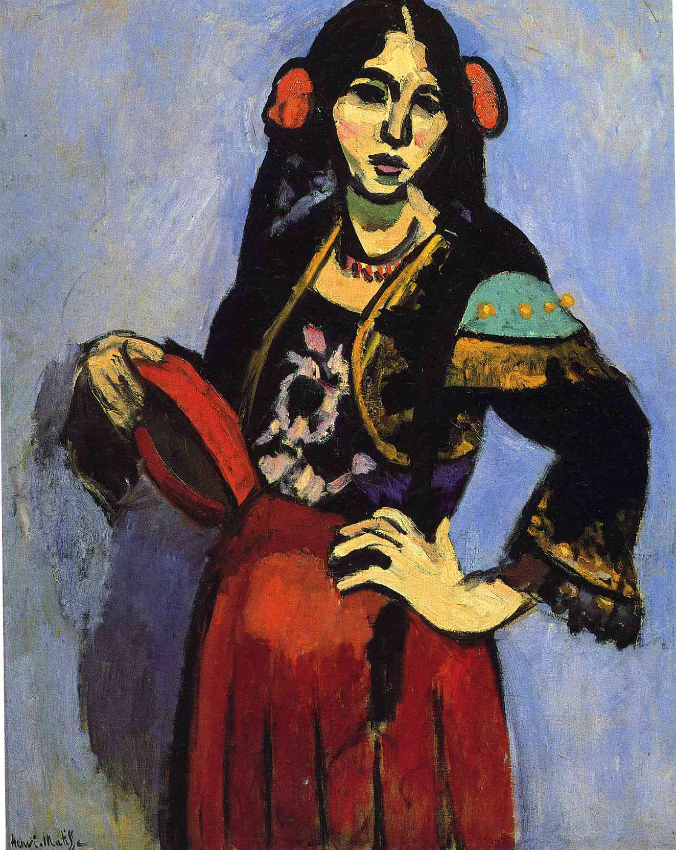 | Closure (Reflecting Anticipatory Set):  To summarize this lesson, the teacher will ask students to complete this sentence: “The Wall of Strengths teaches me ________________________.” These note cards will go under each student’s portrait on the wall.
Lesson Activities & Procedure(s):  - Day One: VTS, True Colors Personality Test  - Visual Thinking Strategy: Spanish Woman with the Tamborine by Henri Matisse.  - Students will take the True Colors personality test to see which personal characteristics are most likely to describe them.  - After students determine their “True Color,” have them divide into teams by color (gold, green, blue, and orange).  - Then ask each color team to plan the perfect vacation.  - Allow each team to share their perfect vacation.  - Students will see that many different types of personalities and strengths make up their class, but each personality has something to contribute that other personalities would not naturally contribute.  - Day Two: Letter to Self  - Now that the students know their personalities a little bit better after the true colors test, students will write letters to themselves to reflect on their personal strengths.  - In the letters students should write about no more than three of their strengths. Rather students should give examples of how they demonstrate only a few strengths.  - Day Two: Student Interviews  - At this point the teacher will pair students (through random selection) to work together for the rest of the lesson.  - Pairs will exchange and read one another’s letters. After they read the letter, students will ask the following questions of their partner:  - What do you see as your greatest strength?  - How do you employ this strength in daily life?  - What more can you tell me about this strength?  - Do you agree with my portrayal (student artist describes their ideas for the portrait) of your strength?  - Is there anything else you would like me to know about you?  - Following the interview, students will make a preliminary sketch of their portrait to prepare for studio during the next two class periods.  - Day Three, Four: Portrait Studio  - Students will use watercolor and crayons to draw the portrait of their partner.  - The portrait should illustrate the outstanding personal strength the artist’s partner highlighted in the student interview. The portrait should also have the name of the student it illustrates easily visible.  - The students will complete the portrait on an 8.5x11 piece of paper.  - Day Five (or Six if students need additional time to complete portraits): Wall of Strengths Reveal  - To prepare for the strengths reveal, the teacher will scan each portrait to enlarge on the smart board.  - The teacher will frame each portrait to hang on the wall in the classroom. Before the students enter the classroom that day, the teacher will cover the “Wall of Strengths” with large paper. After every pairing has presented one another’s portraits, the teacher will uncover the wall. The “Wall of Strengths” will remain up through the entire school year. | Lesson Texts & Materials:  - 8 ½ x 11 inch paper  - Art supplies (watercolor and crayons)  - True Colors Test  - Poster board and markers (for True Colors activity)  - 8 ½ x 11 inch picture fames  - Bulletin board making supplies  - Index cards
Lesson adaptations for challenged learners:  If needed students will be given additional time to complete the portrait drawing phase of the lesson. I don’t want students to feel constrained for time for this assignment. It should be something they enjoy doing.  To assist challenged learners through the “Letter to Self” phase of this lesson, I would make myself available for conferences with each student. In this conference I would help spark students’ thinking about their own strengths. | Lesson extensions/enrichments for gifted learners:  This lesson doesn’t allow students to work too far ahead of other students in the class, but if some students finish their letter or portrait quickly, I would ask those students to help me with a True Colors bulletin board. I would challenge the students to reflect the number of classmates in each color category through a bar graph.
Formative Assessment strategies:

In this lesson formative assessment involves the teacher pushing students to think deeply in each phase of the lesson. If I see students not putting a lot of thought into the letter, interview, or portrait, I would ask the students to push their thinking and see if they can relay their message even more clearly.

